SCIENCE POLICY

Approval Date: | Autumn 2023
Review Date: | Autumn 2025

Psalm 111:2
Great are the works of the Lord, studied by all who delight in them.

POLICY & PROCEDURE

Creating active, knowledgeable and curious scientists, who question, explore and investigate to help them understand and explain God’s world.

For the children at Churchfields, The Village School we believe that science means exploring, discovering, investigating and understanding the world around them through the specific disciplines of biology, chemistry and physics. Science is a largely practical subject that involves children doing things themselves. Enjoyable science activities will increase and develop secure knowledge and enable them to use the skills associated with scientific methods of enquiry and investigation. Working with others, learning to persevere and learning how to ask questions are attitudes that encourage work to be carried out in a scientific way to gain an understanding of scientific processes and the uses and implications of science, today and for the future.

A. AIMS/INTENT

To develop a policy and practice which promotes:

- The development of appropriate scientific skills
- Knowledge and understanding in science and an appreciation of its increasing contribution to all aspects of life
- Positive attitudes to science by all children
- The ability to work through a scientific process
- The application of basic skills of numeracy and literacy

In 2019-20 we embarked on the Primary Science Quality Mark and in the process of gaining Gilt status formulated a set of Science Principles. (See Appendix 1)

B. GUIDELINES/IMPLEMENTATION

Knowledge and understanding

A Long Term Plan for science (see appendix 2) has been devised to ensure coverage of the National Curriculum programmes of study, and to allow for consolidation and progression through both key stages in our mixed year group classes. Teachers are free to change the order units are taught in each year to make cross curricular links as long as all areas are covered over the specific year.

A medium term scheme of work identifies the science objectives for the unit of learning. Science skills (working scientifically) are taught continuously through, and clearly related to, the teaching of substantive science content in the programme of study.

Positive attitudes we hope to encourage and develop include:

- Enjoyment
- Independence
- A curiosity about interesting, new or unusual happenings
- A willingness to respect, co-operate and collaborate with our peers
- Self motivation and perseverance
- Open-mindedness and reflection
- Self appraisal
- To care and respect for the living world and concern for the whole environment
- Creativeness and inventiveness
- Increasing confidence to express ideas and opinions in a supportive atmosphere
- High expectations (do our best)

Children will need to use regularly the process skills of:

- Raising questions, making predictions and testing hypotheses
- Observing – using all senses, sorting and classifying, with increasing detail and noting changes as well as cause and effect
- Measuring and manipulating variables
- Recording their results and communicating to others in a variety of ways (written, oral, pictorial etc.)
- Designing and carrying out investigations
- Interpreting and evaluating their results and drawing conclusions
- Using ICT
- Researching
- Assessing risk to work safely

Teaching strategies and planning

The teachers acknowledge and believe that children naturally have their own prior ideas to share, discuss and investigate and these should be taken into account when planning lessons throughout a unit of work. A ‘Science Floor Book’ can be found in each classroom which, records pupils’ ideas, discussions and explorations and complements their recording in their individual science exercise books. (See appendix 3)

We base our teaching on the National Curriculum. A variety of planning resources including both online and published materials are available to support teachers planning and delivery of lessons.

Variety

It is important that the teacher identifies the most important strategy to suit the purpose of a particular learning situation.

There are a variety of ways in which the teaching may be effective and our school has a tradition of a hands on approach. It is however, frequently acceptable to use demonstration, research, exploration, and teacher-led discussion and investigations when circumstances, resources and the needs of individual groups allow.

Working scientifically is at the heart of science teaching. As a staff we will ensure that it is taught through contexts taken from the knowledge required in the National Curriculum, and that children receive the required balance of knowledge, understanding and skills through the disciplines of
- Biology
- Chemistry
- Physics

Children in EYFS and at Key Stage 1 will be introduced to science through focused observation and exploration of the world around them. This will develop into supported investigations (by the teacher) which at Key Stage 2 will develop into more independent investigations.

Children will be involved in a variety of activities and investigative work:

- Activities to develop understanding of a concept
- Activities to widen our knowledge and understanding
- Activities to develop good observational skills
- Basic skills practice e.g. measuring temperature
- Open ended investigations

Early Years Foundation Stage

Reception children are in mixed year classes and should be involved in any science activity which has an appropriate interest value and which has the capacity to develop essential early skills. The Reception teacher delivers an overlapping curriculum that draws from the objectives in the Early Years Foundation Stage, The National Curriculum and uses the school’s long term plan to provide play experiences, continuous provision and other activities appropriate to each child.

Relevance

Wherever possible, scientific work undertaken by the children will be set in the context of their everyday world.

Differentiation and SEN

Equal access for all children has to take into account the need for differentiation and adaptive teaching.
With mixed ability classes there is a need to structure activities to ensure success for all children, allowing, for the very able children, to undertake work of a more challenging nature where appropriate. For those children with special educational needs (whether they are learning, behavioural or physical) there is a need to consider staffing provision and classroom support for science activities. We recognise that children with literacy and /or numeracy difficulties can, with appropriate support, readily demonstrate their skills, knowledge and understanding in science.

We may differentiate and adapt teaching by: dialogue, allowing more time for tasks, setting one task that has a variety of levels associated with it, asking different levels of questions, giving different tasks to groups, varying the level of adult support, expecting a different level or detail of recording, providing alternative recording methods etc.

Teachers’ short term planning should show how the activities have been adapted or extended for children of different needs and the National Curriculum and the long term plan helps to outline the progression of ideas and skills in science through the Primary school years.

Cross curricular links

Science pervades every aspect of our lives and cultures. It is present in every part of the curriculum. We will endeavour to show scientific discovering and progress from all parts of the world throughout history, and by all genders, from a range of cultures and ethnicities. It is also important to link science in the classroom to the way science has a both negative and positive worldwide impact. However, it is important that links between subjects should be genuine rather than tenuous and contrived.
Each unit of work requires acquisition and application of scientific vocabulary and language. The National Curriculum indicates the words that children should be introduced to in the course of the unit and enables planning in the progression and use of technical and scientific language. The ASE PLAN materials also provide a good point of reference for the teaching of appropriate vocabulary and this has been incorporated into the school Scheme of Work. Science can provide a meaningful context for the teaching of English skills, both within the science session and English lessons.

Safety and Risk Assessment

We recognise that all teachers have to plan safe activities for science. We will therefore refer to the “Be Safe” guide from the A.S.E. (in the school staffroom), CLEAPSS Model Health and Safety Policy in Science for Primary Schools (both with the teachers’ science reference materials), Guidance for Schools Health and Safety

C. RESOURCES

Each class has access to the central resource area. The children are encouraged to choose from a selected range of equipment when designing, planning and carrying out investigations. Children will be trained in the safe and considerate use of living things and equipment and not to be careless with consumables. All staff are responsible for the tidiness and safe storage of science resources. They should indicate to the subject leader resources required. There is capacity in the science budget to enable purchase of consumable resources as and when required for individual lessons.

Learning Outside the Classroom and Visitors

We have a local environment rich in resources for scientific study and make use of visits outside school to provide stimulation and to foster children’s respect for the environment. Some suggestions for LOtC opportunities are included on the Long Term Plan. Visitors are actively sought out to enable children to see scientists in action in chosen careers and to share specific expertise and knowledge.

D. ASSESSMENT, RECORDING AND REPORTING

Opportunities for formative assessment should be identified when planning and the teacher will assess children continuously using AfL strategies. The ASE PLAN Materials and exemplification of standards materials from the DfE are a valuable resource as well as the Bath TAPS materials. Assessment may be through discussion, questioning, work scrutiny and marking against a learning objective, observing pupils carrying out tasks, pupils self-evaluations. Each child has a science book which contains evidence of their scientific activities and achievements. Each class teacher also maintains a class ‘Science Floor Book’ to help record discussions, practical activities, visits etc.

One sheet feedback and marking records help the teacher assess, record next steps, address misconceptions and note down attainment below and beyond expectations. This sheet takes into account not only what is recorded in pupils’ books but also what has been observed, discussed or shared in the floor books. It also helps the teacher adjust planning, address misconceptions and focus on groups of children or individuals to act upon feedback.

Teacher assessments and pupil attainment will be tracked using the Summative Assessment Recording Sheets to facilitate monitoring of attainment and progress in each school year. Children attaining at a greater depth in age related expectation and those below expectations will be noted individually.

A comment on each pupil’s progress and attitudes in science will be made on their annual report. A summative assessment of attainment against “Age Related Standards” is reported to parents at the end of each key stage.

E. ROLES

Headteacher and Governing Body

The role of the headteacher is vital to the development of science or any other curriculum area in school. The headteacher values science in its own right and in relation to other areas of the curriculum and ensures that finance is available for adequate resourcing and CPD. The science leader will help inform and report to the Governing body when requested to help in their monitoring of standards and strategic overview of the school curriculum development.

Subject Leader

- Monitor, evaluate and support teaching staff throughout the year on a formal and informal basis.
- Select and organise resources, and advise on their care and use.
- Plan and implement INSET/workshops.
- Attend meetings related to the science curriculum and liaise with other schools
- In consultation with the staff draw up, monitor the implementation of and review the science policy.
- Detail a Long Term Plan in the light of the requirements of the National Curriculum and Early Years Foundation Stage and check that there is progression so that all children are challenged appropriately
- Keep up to date with the demands of the National Curriculum and Early Years Foundation Stage, and developments in primary science teaching and learning.
- Give advice on the assessment of children
- Act as a source of reference
- Collect records of scientific activities followed by each class

The effectiveness of the science curriculum and its delivery will be evaluated in discussion with the headteacher and members of staff and pupils through the schools moderation and monitoring schedule. From this, actions and CPD needs should be identified and prioritised in the subject leaders action plan which can feed into the school development plan.

Class Teachers

They should teach the science curriculum in stimulating surroundings, recognise interests and encourage scientific enquiry skills.
Class teachers should feel free to share their views with the subject leader and other members of staff so that documentation reflects the views of all ensuring we are all working towards the same aims and purposes.

F. IMPACT

Our Science Principles neatly sum up what we expect from Science teaching and learning at Churchfields.

For our Churchfields pupils we aim to secure knowledge and understanding, to inspire and stimulate curiosity, foster independence and encourage questioning about the world around them. It is our duty as educators to develop and build children’s Science Capital so that they are enthused and enabled to appreciate and pursue science learning in the future and understand its application and importance in our daily lives.

APPENDIX 1:

Creating active, knowledgeable and curious scientists, who question, explore and investigate to help them understand and explain God’s world.

Our Science Principles

Effective Science learning takes place when…

- Pupils and teachers are enthusiastic and engaged in learning activities and our curiosity is stimulated.
- Children readily raise questions and are encouraged to ask and answer questions through research and hands on activities
- Children’s skills and knowledge are combined in practical hands on learning activities
- Children are inspired find out more about their science learning independently or shared further with their parents and carers at home
- Children deepen their understanding as learning is memorable and progress is made because teachers are clear about prior learning and next steps
- Children and teachers make links to other areas of the curriculum and real world applications and examples
- Quality science resources , including visits, visitors, technology and the outdoors are accessible and used frequently
- Science is celebrated throughout the school in e.g. Science week, displays and communications from school to the wider community – we share the AWE and WOW! of science
- Children and teachers confidently communicate science thinking using appropriate science vocabulary
Pupil Voice Version

- I feel enthusiastic, engaged and curious in science lessons.
- I am encouraged to ask questions when researching and taking part in experiments.
- I use my science skills and knowledge in experiments.
- I am inspired to learn more about science topics outside of school and share my understanding with adults at home.
- I gain new knowledge, understanding and skills and build on what I already know.
- I understand how science at school is connected to science in the real world.
- We use a variety of resources in science lessons including using the outdoors, technology and have science visitors in school.
- I can share my science learning in school in Gem Learner assemblies and I see my work on displays.
- I speak confidently in science using scientific vocabulary.
APPENDIX 2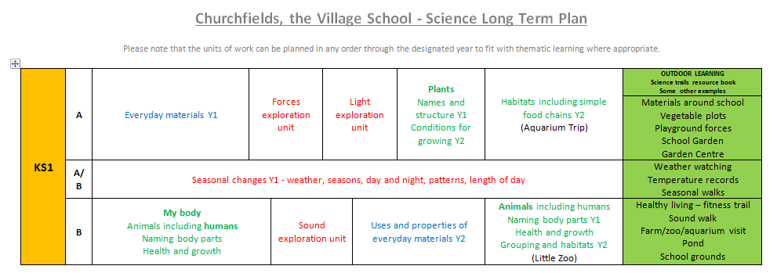
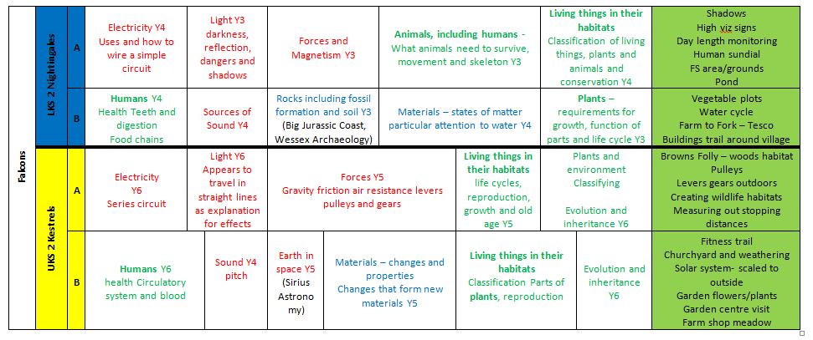

APPENDIX 3:
Why use Floor Books in Science?

“Using floor books in science promotes the development of children’s ideas, thinking and reasoning skills, models the collaborative nature of science and supports effective teacher assessment.”
Alison Trew & Caroline Skerry (Fellows, PSTT)

Using floor books in science can:
• Provide an insight into children's scientific enquiry skills and their conceptual understanding of science processes though photographs and children’s comments: some of these skills are only evident when children are talking and doing
• Provide evidence of all types of scientific enquiry over the course of a year: floor books are especially helpful for children who can explain their science investigations orally but may struggle to present their work in written form
• Support teachers’ assessment: by making it easier to track developments in children's ideas, both individually and as a class; by providing teachers with a large body of evidence on which to make summative judgments about a child's level of achievement over a period of time
• Promote collaboration and group work in science
• Motivate children: an opportunity for reluctant writers to demonstrate their knowledge and skills; celebrate everyone’s learning
• Provide evidence of high-quality science teaching for external accountability (e.g. Ofsted), particularly assessment for learning and responsive teaching
• Enable teachers and pupils to refer to previous learning, including from earlier year groups

Be aware of:
• Differentiation - record one piece of work per ability group where appropriate
• Recording attainment - have a separate assessment file (e.g. for TAPS focused tasks)
• Misconceptions - ensure that these are addressed
• Individual learning evidence - ensure all children are included in the floor book
• Marking – instead of making, spend time after the lesson reviewing the evidence of children’s learning to gain a better insight of the children’s understanding and possible misconceptions

Churchfields floor books for science will:

- Have the date and LO WS and knowledge clearly stated
- Have photos, drawings
- Referred to in teachers planning and evaluation notes
- Have comments either written by children or scribed for them
- Have egs of learning from a range of abilities/attainment
- Be referred to regularly
- Used to record existing knowledge and show progress from referring back to prior learning
- Include all children and abilities
- Are working documents and although not expected to be “display standard” should meet the expectations we have for all children’s books
- Should always be presented alongside children and their own books when a learning conversation, book scrutiny etc is carried out

