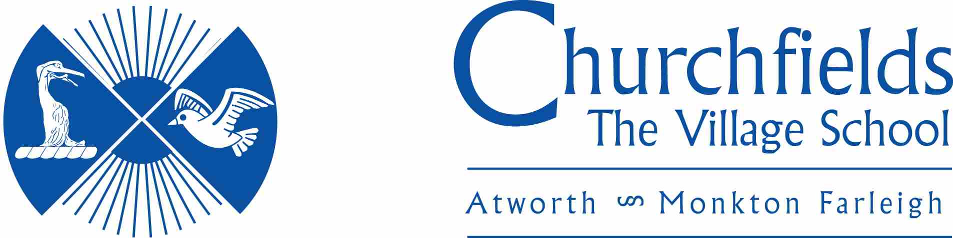

CREATIVE ARTS POLICY

Approval Date: | Autumn 2023
Review Date: | Autumn 2025

Isaiah 64:8

But now, O LORD, You are our Father, We are the clay, and You our potter; And all of us are the work of Your hand.

POLICY & PROCEDURE
Rationale
We are committed to provide all our learners with a motivating and inspiring creative curriculum that aims to develop thoughtful and responsible young people with high self-esteem and the skills and knowledge to succeed in life.
Creative Arts Education can be:
- The delivery of the Arts under curriculum headings, commonly Art, Dance within P.E., Drama and Music
- An experience which draws on a number of these curriculum areas, e.g. creating a piece of visual art from a music stimulus
- Contributors from Arts areas to other curriculum areas e.g. drama enhances the history experience
It is likely to be a combination of all these approaches.
Learning in the Arts is developing skills which will enable children to engage in the process of the Arts; is widening knowledge and understanding of the Arts and is developing critical responses to the Arts. Learning through the Arts is the exploration of issues, ideas and values through dance, drama, music etc.
Aims
- Facilitate the opportunity to participate in and experience a broad and balanced range of arts activities as part of a rich exciting curriculum.
- Plan opportunities for learners to be creative and creatively express themselves in and through all art forms.
- Provide a powerful tool which can support a progressive range of skills such as the development of knowledge, concepts and skills, and enhance the learning process across the curriculum.
- Offer opportunities for learners to express themselves, enjoy themselves and be successful.
- Enable individuals and groups of learners to achieve excellence and enjoyment.
- Offer opportunities for individuals and groups of learners to be involved in performance.
- Provide opportunities for children to perform to their peers and to parents at a variety of venues both in school and in the wider community.
- Enable children to be creative through composition and performance
- Enable learners to develop their intellectual, aesthetic and critical faculties through active participation in the Arts.
- Encourage the use of the Arts as an effective medium for achieving other educational objectives.
- Enrich the curriculum for all learners through activities that access all areas of the curriculum, different cultures and those that reflect our local community.
- Help develop a respect for others’ artistic tastes and points of view.
Teaching and Learning
Teaching at all levels should include a variety of teaching styles making the lessons suitable for all learners, regardless of ability.
The various techniques should include opportunities for:
- Group, individual and whole class activities as identified within lesson plans
- Collaboration with schools within the cluster
- Discussion with the group and individual learners as well as through demonstration and instruction
- Individual research and exploration
- Use of a variety of media (TV, DVD, radio, Internet) to enhance the learners understanding
- The development of computing capability through Arts Education through the use of computers, CD players and tape recorders, MP3 players, microphones, sequencing programs, keyboards, lighting techniques etc
- Enhancing a child’s self-esteem by promoting success in achievement and enjoyment in learning.
- Equipping learners with skills to interact with others, thereby developing a sense of purpose and belonging
- Valuing their own work and that of their peers
- Celebrating Arts Education by exhibiting, performing and presenting their work to represent their achievements in various forms both in school and in the wider community. These can be provided through the following means:
    - Arts Festivals
    - Assemblies
    - Concerts
    - Exhibitions
    - Displays
- Extra-curricular activities for those learners who demonstrate a particular interest or ability, e.g. Music/drama groups, extended services and clubs
- Using expertise and knowledge from within and outside the school
- Access to a variety of experiences within an arts setting
- In music teaching and learning are achieved through a high level of practical work. The teacher performs regularly to children to demonstrate and model musical ideas and to inspire
- Children are provided with suitable musical instruments which they use to perform and compose
- During Singing Assembly, all children sing together and learn songs as a community, with opportunities for gifted and talented to sing in harmony and solos during performances
Early Years Foundation Stage
The Arts will be taught in a variety of ways in the Foundation Stage through many areas of the Early Years Foundation Stage curriculum. The Arts will have a particular focus on the teaching and learning of Personal, Social and Emotional Development, Creative Development, Physical Development and Communication, Language and Literacy. To reflect the catchment area of the school, there will be a prevailing focus on the development of learner’s speaking and listening skills to equip them with the necessary tools for expression to succeed further up the school and into adulthood.
Progress and Achievement
In the short term, teachers will carry out continuous assessment of learner’s progress in all aspects of the Arts Curriculum, where appropriate this will be noted down on weekly planning sheets. Such assessment will be formative and be rooted in Assessment for Learning. In addition, all learners will be encouraged to assess their own and others’ learning against learning objectives. Self-assessment could take the form of traffic lighting or thumbs during plenaries, verbal feedback or peer marking/editing.
Assessment
Assessment will be part of a continuous process which both reinforces teacher/pupil planning and provides clear information for others.
Outside Agencies
The school has links with a number of outside agencies to promote and enhance the delivery of the Arts. These include:
- Library services
- Museum Services
- Visiting theatre and music groups
- Specialist dance and drama coaches

