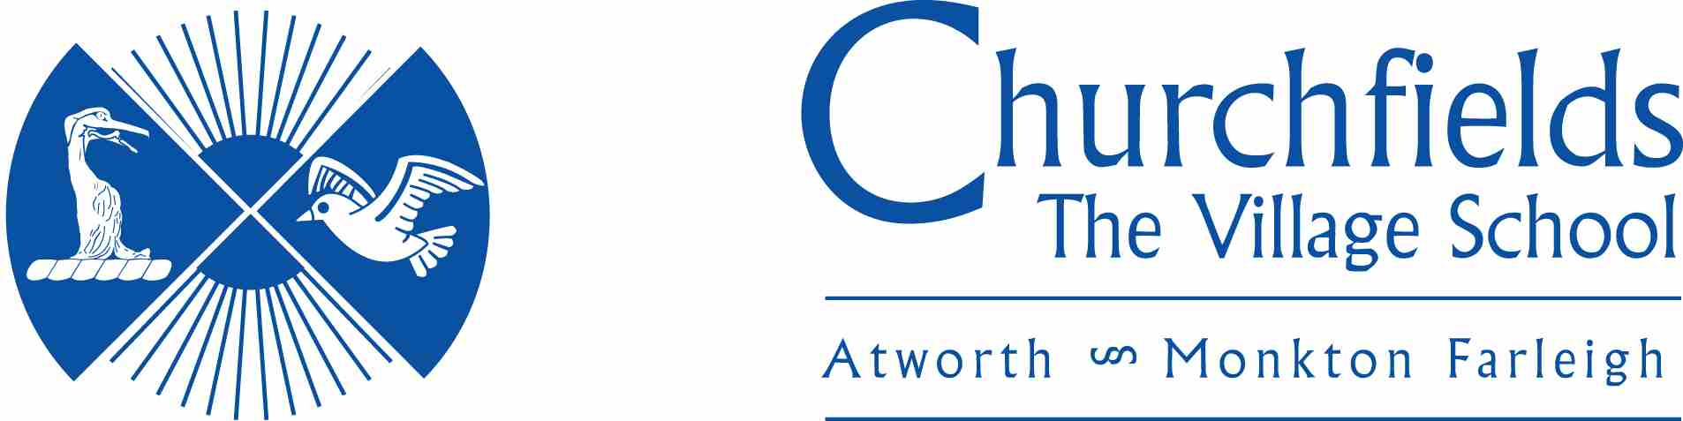

MODERN FOREIGN LANGUAGES POLICY

Current Policy Approval Date:
Review Date:

Introduction

In our school we teach a foreign language to all children in Years 3, 4, 5 and 6 as part of the normal school curriculum. We do this for several reasons. Firstly, we believe that many children really enjoy learning to speak another language. Secondly, we believe that the earlier a child is exposed to a foreign language, the faster the language in question is acquired. We also believe that it is a good idea to introduce a new language to children when they are at primary school, as they tend to be less self-conscious about speaking aloud at this stage of their development. It is widely believed that the early acquisition of a foreign language facilitates the learning of other foreign languages later in life.

Aims and Objectives
The aims and objectives of learning a modern foreign language in primary school are:
- to foster an interest in learning other languages;
- to introduce young children to another language in a way that is enjoyable and fun;
- to make young children aware that language has structure, and that the structure differs from one language to another;
- to help children develop their awareness of cultural differences in other countries;
- to develop their speaking and listening skills; to lay the foundations for future study.

Organisation
French is offered to all children for 30-45 minutes week in key stage 2.
This is taught either by the class teacher or through PPA time, where planning and resources are provided.

The Curriculum
French is the modern foreign language that we teach in our school. The curriculum that we follow is based on the Key Stage 2 Framework for MFL and the revised National Curriculum. We use ‘Le Jolie Ronde’ to support with lessons plans, slides and audio resources. There are times when these resources are supplemented with other learning resources, i.e. The Oak academy and YouTube.

We teach the children to know and understand how to:
- ask and answer questions;
- use correct pronunciation and intonation;
- memorise words;
- interpret meaning;
- understand basic grammar;
- use dictionaries;
- work in pairs and groups, and communicate in the other language;
- examine aspects of life in another culture.

Teaching and learning style
We use a variety of techniques to encourage the children to have an active engagement in the modern foreign language: these include games, role-play and songs (particularly action songs). When possible we use confident French speakers in the classroom, in order to expose the children to more than one voice in the foreign language as well as using DVD’s, interactive resources and CD’s.

We emphasise Listening and Speaking skills over Reading and Writing skills in Year 3 but all four skills, especially independent Reading and Writing become increasingly important with progression year on year. After four years of language learning most children will be able to read and write short passages of familiar French, will have an understanding of some French culture, will have a basic understanding of language structure, which they can apply to another language, will be able to hold a short, simple conversation and understand a range of familiar language.

We also use a multi-sensory and kinaesthetic approach to teaching, i.e. we try to introduce a physical element into some of the games, as we believe that this serves to reinforce memory. We make the lessons as entertaining and enjoyable as possible, as we realise that this approach serves to develop a positive attitude in the children to the learning of modern foreign languages. We build children’s confidence through constant praise for any contribution they make in the foreign language, however tentative.

Assessment
We assess children’s progress formatively in order to ensure that they are moving forward in the learning process. This is done informally during the lessons in order to evaluate what the children are learning and to inform teaching. Assessment is in four key areas:
- listening and responding;
- speaking;
- reading and responding;
- writing vocabulary in LKS2, with full sentences being written in UKS2.

Children are assessed 3 times yearly, using National Curriculum expectations, as well as the skills and knowledge required, which are built on during their time in Key Stage Two.

Monitoring and review
We monitor teaching and learning in the same way as we do all the other subjects that we teach in the school. Regular observations are undertaken by the Head Teacher.

