Dear Parent/Carer,

I hope you had an enjoyable bank holiday weekend. This has been a busy week in school with our year six pupils undertaking their end of Key Stage Two national tests (SATs) every morning. We are incredibly proud at how every child took these in their stride and look forward to celebrating their results with them later in the summer.

Thank you to parents and carers who have volunteered to give at least a little of their time to support the work needed for the reopening of the Atworth base swimming pool. It is not too late to register your help by contacting Emma Bennett on [ebennett@churchfields.wilts.sch.uk](mailto:ebennett@churchfields.wilts.sch.uk) Thank you in advance.

Kind regards,

Simon Futcher.

Tempest Photos 

Tempest Photographers are coming into school on Monday 15 May 2023 for class group Vista photos. They will be at Atworth in the morning before heading over to Monkton Farleigh.

Ordering on-line

Once the photographs have been taken on Monday, parents/carers will receive an email with a link to access the gallery of class vista photos to order photos on-line ready for delivery back to school before the end of term.

.

And it's gold for Falcons this week, with Sam D topping the list of busy mathletes who have been working away improving their maths skills. Well done everyone!

**GOLD** : Sam D

**SILVER** : Theo, Sam D, Sam F, Kaya

**BRONZE** : Bodhi B, Sam B, Theo, Daisy B, Benjamin, Oliver CJ, Sam D, Sam F, Edie, Alexis G, Oliver H, Francis, William J, Leighton, Livinia, India, Ted L, Morgan, Otto, Alexis M, Christina, Joseph, George R, Charlie, Harrison, Jamie, Kaya, Alice





**Wood contributions needed for**

**outdoor learning sessions**

At each outdoor session on Friday afternoon, we try to have a fire. This is a valuable activity to discuss safety, changes in materials and to create a little snack to sustain us through sessions. We do get through kindling and firewood very quickly. If anyone has any wood scraps (not chemically treated) that could be cut up into kindling they would be gratefully received by Mrs Liddiard at either base. Thank you.

Andrea Liddiard

**King Charles III Coronation Celebrations!**

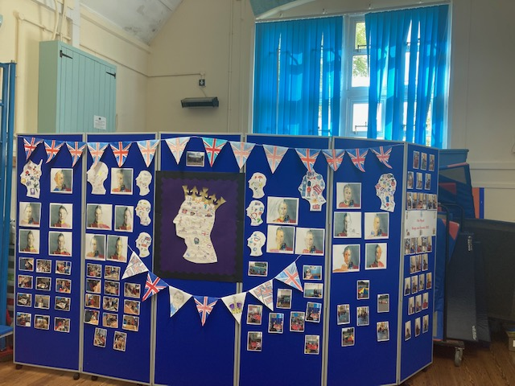

Children enjoyed the celebrations of the coronation and worked together to create incredible art work. Fun and games were had in the afternoon, topped off with afternoon tea.

.



|  |  |
| --- | --- |
| **Term 5: Monday 17 April – Friday 26 May**   * Monday 17 April – children back to school * **Monday 01 May – Bank holiday (school closed)** * **Monday 08 May – Bank holiday (school closed)** | **Term 6: Monday 5 June – Tuesday 25 July**   * Monday 05 June – children back to school * **Monday 24 July – INSET DAY (school closed)** * **Tuesday 25 July – INSET DAY (school closed)** |

**Term dates for 2023**

| DATE | EVENT |
| --- | --- |
| Monday 01 May | **Bank Holiday (school closed)** |
| Tuesday 02 May | **No Teacher led clubs** |
| Thursday 04 May | **Atworth Coronation celebration** |
| Friday 05 May | **Monkton Farleigh Coronation celebration** |
| Monday 08 May | **Bank Holiday (school closed)** |
| Tuesday 08 May – Friday 12 May | **KS2 SATs week** |
| Monday 15 May | **Class Photos with Tempest Photography** |
| Tuesday 16 May | **KS2 WOW Day** |
| Tuesday 16 May | **Party Games Club with Mrs Reid cancelled** |
| Tuesday 23 May | **Year 7 Reunion at Monkton Farleigh** |
| Friday 26 May | **End of Term 5** |

|  |  |
| --- | --- |
| **Term 6** | |
| **Monday 05 June** | **Start of Term 6** |
| **Tuesday 06 June** | **KS2 Stonehenge trip** |
| **Wednesday 07 June** | **R23 Meet the Teacher 5pm Atworth; 5:30pm MF** |
| **Wednesday 14 June – Friday 16 June** | **UKS2 Residential WOLT** |
| **Tuesday 13 June** | **Atworth R23 Induction afternoon 1pm -3pm** |
| **Wednesday 14 June** | **Monkton Farleigh R23 Induction afternoon 1pm -3pm** |
| **Saturday 17 June** | **Monkton Farleigh Fete** |
| **Tuesday 20 June** | **Atworth R23 Induction afternoon 1pm -3pm** |
| **Wednesday 21 June** | **Cluster music project St Laurence** |
| **Wednesday 21 June** | **Monkton Farleigh R23 Induction afternoon 1pm -3pm** |
| **Tuesday 27 June** | **Melksham Oak taster day YR 6** |
| **Tuesday 27 June** | **Atworth R23 Induction afternoon 1pm – 3pm** |
| **Wednesday 28 June** | **Monkton Farleigh R23 Induction afternoon 1pm -3pm** |
| **Wednesday 28 June** | **ST Laurence YR 5 Cluster Curriculum Day** |
| **Friday 30 June** | **Y6 Corsham induction day** |
| **Tuesday 04 July** | **YR6 leavers trip to Bath** |
| **Tuesday 04 July** | **R23 Teddy Bears picnic 1:30 pm - Both bases** |
| **Thursday 06 July** | **YR6 Induction day St Laurence (1 of 2)** |
| **Monday 10 July to Friday 14 July** | **Sports Week** |
| **Tuesday 11 July** | **Rocktopus** |
| **Tuesday 11 July** | **BMT Piano lessons cancelled at Atworth - (Due to sports week)** |
| **Tuesday 11 July** | **Ukele lessons cancelled at Atworth - (Due to sports week)** |
| **Thursday 13 July** | **YR6 Induction day St Laurence (2of 2)** |
| **Thursday 13 July** | **Move up morning** |
| **Friday 14 July** | **Sports afternoon with PTA event 1pm onwards** |
| **Friday 14 July** | **Pupil Reports go home** |
| **Wednesday 19 July** | **Leavers service St Michaels Church 1:15pm** |
| **Friday 21 July** | **Last Day Term** |
| **Monday 24 July** | **Inset Day** |
| **Tuesday 25 July** | **Inset Day** |

