CHURCHFIELDS THE VILLAGE SCHOOL Key Stage 2
Topic Home Learning Term 1 & 2 2022
To support children’s responsibility and freedom to make choices about their own learning, our topic based homework offers opportunities for children to explore this topic in their own way. Ideas are given around a topic, but children are free to interpret them as they wish. They are designed to allow the children to express their own interests.
Children should complete at least one piece of homework per short term, Presenting their work in class is a fantastic way to develop their speaking and listening skills, and children can celebrate each other’s success.
Science  Investigate a fabric eg cotton, nylon, polyester, wool. Can you find out how it is manufactured? Create a flow chart to show the process.  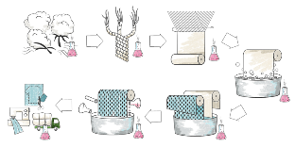 | Don’t forget to read every night and practise your spellings and Maths Passport or login to Mathletics. | Design  Choose a celebrity/well known public figure. Can you design an outfit for them? Think about what image they like to portray to the public. What is the purpose of the outfit? Is it for leisure or an awards ceremony, is it a new team kit for instance…  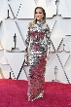
Musician fact file.  Research a band or pop/rock star. How have they influenced fashion.  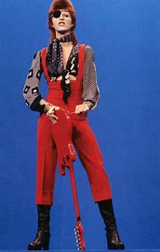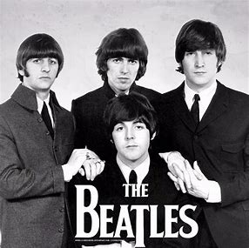 | Research a Fashion Designer  Present the information in a PowerPoint or similar | Create a stitched sampler  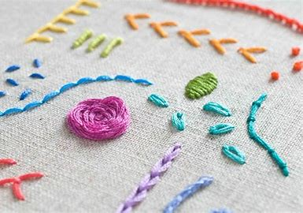
Sustainable clothing  Investigate sustainable issues around clothing and ‘fast fashion’  Sustainable fashion: What are the environmental and social impacts of your clothes? - BBC Bitesize  Create a poster or advert persuading people to consider carefully their fashion choices | Where have your clothes come from?  Look at labels in clothes find out where they were manufactured. How many miles have your clothes travelled? Can you find these places on a world map. | Go Shopping! (virtually)  Imagine you are going to a posh event such as an awards ceremony, a wedding etc. Make shopping list cost it up. Make two lists one with an outfit that costs as little as possible and one where the sky is the limit!
Interview  Interview a member of your family. Discuss what they wore when they were younger. Maybe they have some photos! Were their fashion choices influenced by celebrities, sports stars or pop stars of the time? Write up the responses to share with the class.  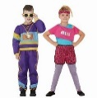 | Your own idea | Upcycle  Can you take an old garment and upcycle it into a new garment, toy or accessory?  