CHURCHFIELDS THE VILLAGE SCHOOL Reception, Year One and Year Two
Topic Home Learning Term 1 & 2 2022
Topic-based homework offers the children a chance to explore their learning in their own way and to undertake more collaborative projects if they would like to. They are designed to allow the children to express their own interests. Ideas are given around a topic, but children are free to interpret them in their own way.
In response to parent feedback, we have also included some more structured formats as suggestions for those who would prefer greater guidance.
Children should complete at least one piece of homework per short term, Presenting their work in class is a fantastic way to develop their speaking and listening skills, and children can celebrate each other’s success.
Model  Make your own Superhero toy/puppet  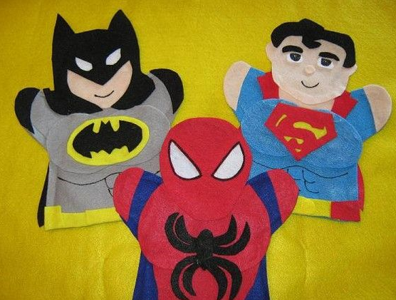 | Don’t forget to read every night and practise your Maths Passport or login to Mathletics. | Model  Make a vehicle for a Superhero. Remember to give it some special features.  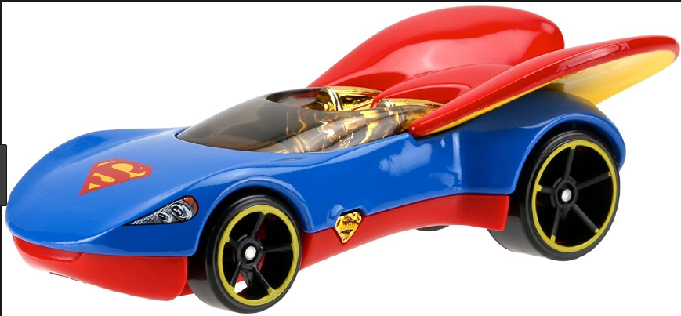
Creative writing  Write your own Superhero story. | Design and make  Make a Superhero headquarters.  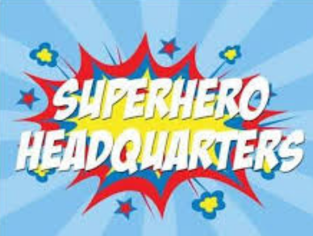 | Creative writing  Make your own Superhero rules.  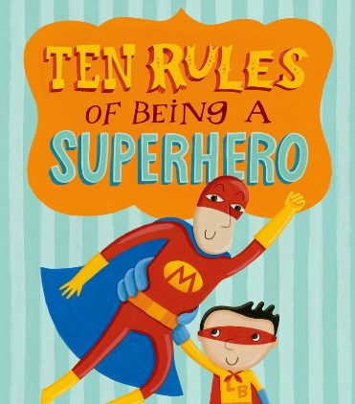
Discuss  Find out what special powers the people in your family would like to have if they were Superheroes.  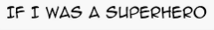 | Create  Make a comic strip of your favourite Superhero or of a Superhero of your own.  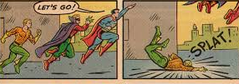 | Powerpoint  Who is your hero? E.g. a nurse, doctor, teacher, Scientist or environmentalist Find a picture and write a few sentences to explain why you chose them.  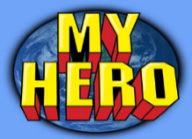
Reading  Extreme reading challenge- collect photos of yourself reading in extreme places- e.g. up a tree, on a trampoline, in a cupboard, where do you think a Superhero would read a book? | Your own idea  For example, write a letter to someone you admire e.g. Steve Backshall or Greta Thunberg. | Design and make  Create Superhero accessories for you to wear- e.g. jet mask, cape or cuffs.  