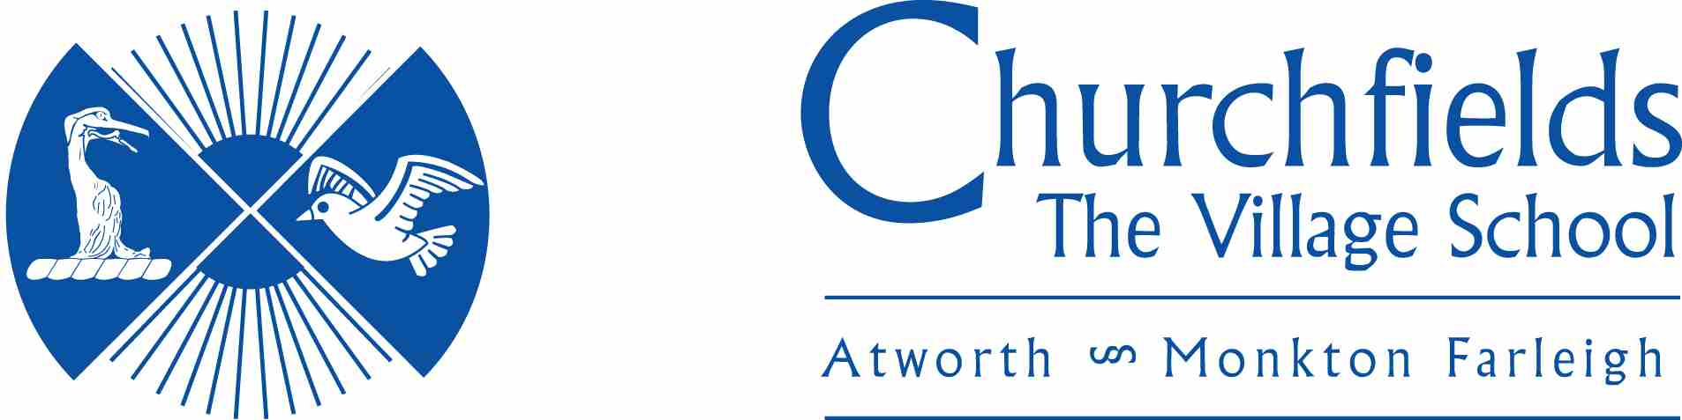

Food Policy

Approval Date: | Spring 2022
Review Date: | Spring 2025

Why is a policy needed?

At Churchfields we recognise the important part that a healthy diet plays in a child’s well being and their ability to learn and achieve effectively. We believe that the school, in partnership within parents and carers can make a major contribution to improving children’s health, including their oral health, by increasing their knowledge and understanding of food and helping them to make healthy food choices.

National Guidance

This guidance has been written to reflect the School Food Standards and the Eatwell Plate Model of Healthy Eating. The policy supports Ofsted’s commitments to assess pupils’ knowledge of how to keep themselves healthy and our school’s ethos of healthy eating.

Application
This policy covers the areas of:
- Breaktime snacks including those brought from home.
- Milk
- Water
- School Lunches including packed lunches
- Curriculum
- Before and after school clubs and events
- Events and celebrations
The policy applies to all staff, pupils, parents, governors and partner agencies working within school.

Break time snacks
All Foundation Stage and Key Stage 1 children are provided daily fruit or vegetables as part of the Government scheme.
Any snacks that are brought from home should be healthy e.g. fruit or vegetables.

Milk
Our school provides a milk scheme (Cool Milk) for all pupils, in accordance with Government guidelines. Parents are invited to register and pay for their child to participate in this scheme, which provides a carton (189ml or 1/3 of a pint ) of semi skimmed milk every day for Reception and Key Stage 1 children. Parents can specify if an alternative type of milk is required e.g. full fat. Children of those families in receipt of Free School Meal are eligible for free milk.

Water
Clean filtered drinking water will be available for all pupils throughout the day and pupils will be encouraged to drink water at frequent intervals. All packed lunch pupils have access to water at lunch time meaning there is no need for an additional drink to be brought as part of a packed lunch. Pupils are encouraged to bring a water bottle every day that they can refill as necessary. Bottles go home at the end of every day to be washed and returned.

No drinks other than water will be brought into school by pupils unless recommended by a doctor for medical needs. This supports a healthy lifestyle including oral health.

School lunches including packed lunches

At Churchfields, all school meals will be prepared following the government nutritional guidelines.

We will provide Universal Free School Meals for children in Reception and Key Stage 1, and encourage parents to take up this offer. We are committed to providing food which is compliant with all national guidelines.

Staff will work with children to provide a clean and safe dining area. We believe that lunchtimes should foster the caring, friendly ethos that governs everything that we do. Children are encouraged to be independent during the meal times as appropriate.

Some families prefer to provide a packed lunch, and we are aiming for our packed lunches to be as healthy as they can be. Packed lunches provided for school trips as part of our Free School Meal provision comply with National Food Standards.

Any meals taken as part of on or off school site residentials will provide a balanced and healthy approach to meals and, where possible, we will look to use off site providers that comply with the National Food Standards.

Curriculum
Food, its production and preparation is an important part of the curriculum for all pupils and is taught across the curriculum through Science, PHSE, PE and Design and Technology. We reinforce our delivery of the National Curriculum by holding a Healthy Schools Week annually which enables us to focus on all aspects of wellbeing, including healthy eating. Children will be taught the importance of a balanced diet and what this consists of.

Children will also be taught specifically about the importance of oral health from a young age in school. They will be taught how to look after their teeth by effective brushing and visits to the dentist, and which food choices best support oral health.

Events and Celebrations
We want to give children the opportunity to celebrate their birthdays but to promote healthy eating choices, we request parents consider healthy alternatives to cakes and sweets. we would ask that parents and carers do not send in birthday cakes or sweets. If parents want to bring something in to celebrate birthdays, we ask that healthy foods such as fruit or non-food items such as stickers, a special book for the class or colouring pencils are considered as alternatives.

At Christmas and at the end of the school year, classes may have a class party in which food is brought in by parents. We will provide a balance between treat foods and healthy fruit and vegetables at these times.

Monitoring
We consult annually with caterers, pupils, parents / carers and staff, and involve them in reviewing school meals. The results are used to evaluate the impact of the food policy and to further improve school meals.

