Put together the plant.
Cut the parts out and stick them together to make a complete plant. Can you label the parts? Do you know what each part’s purpose is?
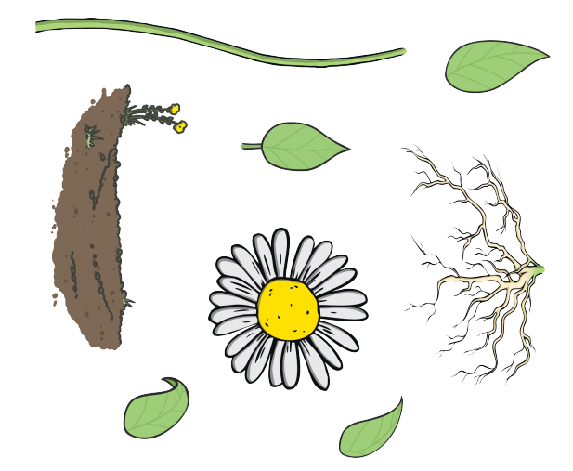
Choose a plant from your garden. Can you draw and label its parts. What is the name of your plant?

