**Fill In The Blanks**

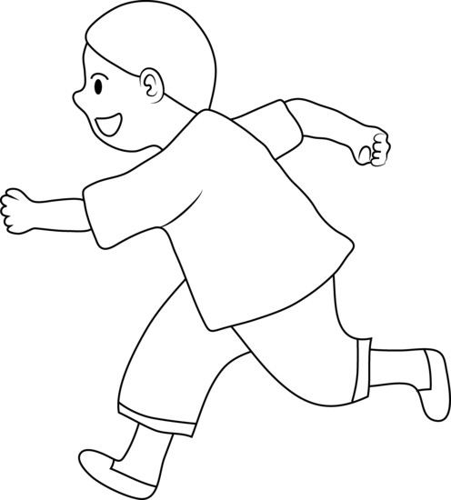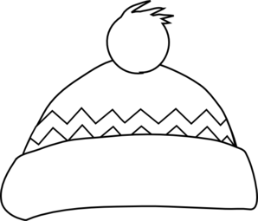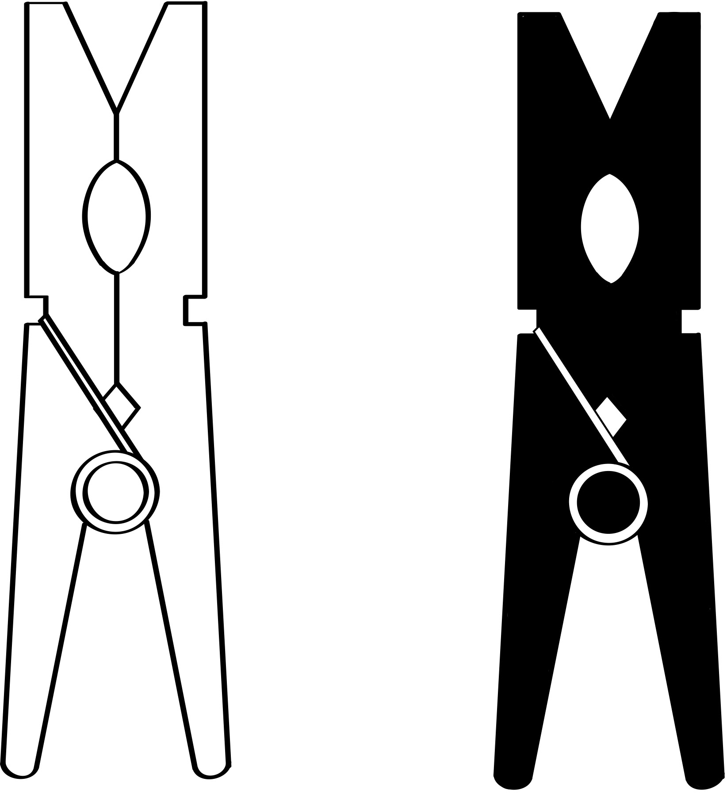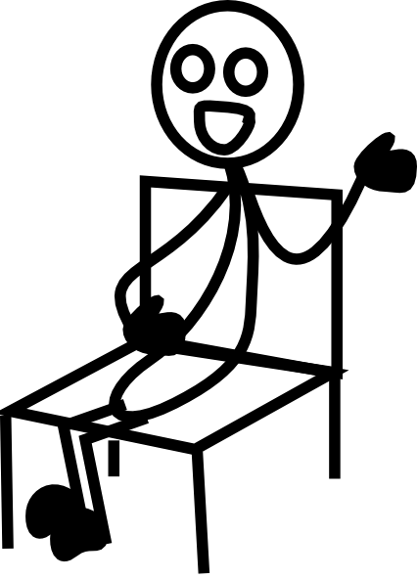

1. The boy can _ _ _.
2. I have a _ _ _for winter.
3. She was _ _ _ on a chair.
4. I hang up the clothes with a _ _ _ .